COMBINATION SUM PROBLEM
USING BACKTRACKING
Q9 – Backtracking
Name: L. Ashraf Ali
Register No.: 192524192
Pseudocode, Algorithm, Output, Analysis and Documentation

1. Aim
To find all unique combinations of numbers whose sum is equal to a given target using the Backtracking technique.

2. Problem Statement
Given a set/list of positive integers and a target value, find all possible combinations of the numbers that add up exactly to the target. A number may be reused multiple times, and duplicate combinations must not be included in the output.

3. Inputs
- numbers – a set/list of positive integers.
- target – the required sum.

4. Output
All unique combinations whose elements add up exactly to the given target.

5. Constraints
- Only positive integers are considered.
- A number can be selected more than once.
- The order of numbers in a combination does not create a new solution.
- Each valid combination must have a sum exactly equal to the target.
- Duplicate combinations must be avoided.

6. Pseudocode
ALGORITHM CombinationSum(numbers, target)
INPUT:
numbers = set/list of positive integers
target = required sum
OUTPUT:
All unique combinations whose sum equals target
BEGIN
Sort numbers in ascending order
result ← empty list
current ← empty list
PROCEDURE Backtrack(start, remaining)
IF remaining = 0 THEN
Add a copy of current to result
RETURN
END IF
FOR i ← start TO length(numbers) - 1 DO
IF numbers[i] > remaining THEN
BREAK
END IF
IF i > start AND numbers[i] = numbers[i - 1] THEN
CONTINUE
END IF
Add numbers[i] to current
Backtrack(i, remaining - numbers[i])
Remove last element from current
END FOR
END PROCEDURE
Backtrack(0, target)
RETURN result
END

7. Branching and Recursion
At each recursive step, the algorithm selects one candidate number from the current starting position onward. The selected number is added to the current combination and the remaining target is reduced. The same index i is passed to the recursive call so that the selected number can be reused.

8. Pruning Conditions
Pruning 1 – If numbers[i] is greater than the remaining target, the loop is stopped. Since the numbers are sorted, every later number will also be greater and cannot produce a valid combination.
Pruning 2 – If the current candidate equals the previous candidate at the same recursion level, it is skipped. This prevents duplicate combinations when the input contains duplicate values.

9. Duplicate Avoidance
Sorting places equal values next to each other. The condition i > start and numbers[i] = numbers[i-1] skips repeated choices at the same recursion level. Passing i rather than i+1 permits reuse of a number while still maintaining nondecreasing combination order.

10. Example Input
numbers = [2, 3, 6, 7]
target = 7

11. Example Output
[2, 2, 3]
[7]
Both combinations have sum 7: 2 + 2 + 3 = 7 and 7 = 7.
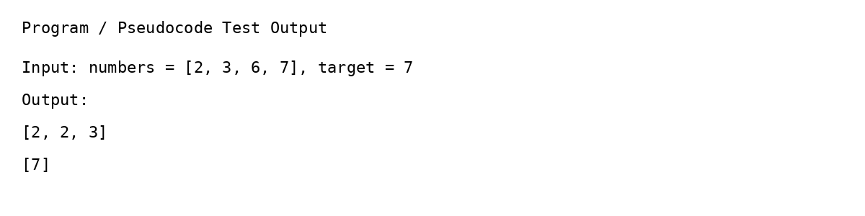
Figure 1: Example output screenshot.

12. Correctness Analysis
The backtracking procedure considers every possible candidate starting from the current index. A candidate is added, the remaining target is updated, and recursion continues until either the target is reached or the branch becomes impossible. Because all candidates are explored unless safely pruned, every valid combination is found. Sorting and duplicate skipping ensure that the same combination is not produced more than once.

13. Efficiency Analysis
Aspect | Analysis
Time Complexity | Exponential in the worst case because the number of possible combinations can grow rapidly with the target and input size.
Space Complexity | O(T) approximately for recursion depth when the smallest positive number is 1, excluding the output list.
Pruning Benefit | Sorting and stopping when a candidate exceeds the remaining target avoid many impossible recursive calls.

14. Documentation
Function: CombinationSum(numbers, target)
Purpose: Generate every unique combination whose sum equals target.
start: Index from which candidates may be selected.
remaining: Target amount still required.
current: Combination currently being constructed.
result: Collection containing all valid combinations.

15. Conclusion
The Combination Sum Problem can be solved using Backtracking by recursively selecting candidates and undoing each choice after exploration. Proper branching ensures completeness, while sorting and pruning reduce unnecessary computation and prevent duplicate solutions. The approach is simple, systematic, and suitable for demonstrating recursive search.

16. Student Details
Name: L. Ashraf Ali
Register No.: 192524192

